TECHNOFIST a leading student’s project solution providing company established in Bangalore since 2005. With perfect infrastructure, lab set up, Work shop, Expertise faculties make our self competitive service providers.
We offer projects for all branches of Engineering and Diploma students.
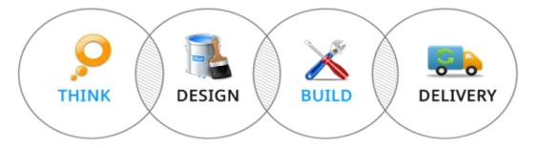
DOORS OF TECHNOLOGY:
- EMBEDDED SYSTEMS  - MICROCONTROLLERS / ARM /PIC / AVR  - WIRELESS TECHNOLOGIES  - ROBOTICS  - ARDUINO  - GSM & GPS/ ZIGBEE  - MATLAB / VLSI | - IEEE PROJECTS ON JAVA / DOT NET  - JAVA AND DOT NET APPLICATION PROJECTS  - ANDROID BASED PROJECTS  - PHP  - C,C++  - AND COMPLETE MECHANICAL FABRICATIONS
Projects are available for all branches of ENGINEERING, DIPLOMA, MCA/BCA, and MSc/BSc.
CORPORATE OFFICE:
TECHNOFIST
YES Complex,
#19/3&4, 2nd Floor,
Dinnur Main Road
R T Nagar Post
Bangalore – 32
=====================================================================
Support : 080-40969981 Sales :+91-9008001602
www.technofist.com ww.technofist.in www.itcdp.in info@technofist.com
=====================================================================

PROJECT LIST
SL No | CONTENTS
1  2  3  4 | SOFTWARE PROJECTS  - JAVA, J2EE  - PHP  - DOTNET  EMBEDDED PROJECTS  - ARM BASED PROJECTS  - ANALOG AND DIGITAL ELECTRONICS PROJECTS  - MICROCONTROLLER BASED PROJECTS  - IEEE TRANSACTIONS ON ROBOTICS  - IEEE TRANSACTIONS ON GSM  - WIRELESS BASED PROJECTS  - CELL PHONE BASED PROJECTS  - SMART CARD/ RFID BASED PROJECTS  - BIO-METRIC / BIO-MEDICAL BASED PROJECTS  - CAN PROTOCOL BASED PROJECTS  - GSM AND GPS BASED PROJECTS  - MICROCONTROLLER BASED ELECTRICAL  - BLUETOOTH BASED PROJECTS  - ZIGBEE BASED PROJECTS  - CAPSENSE, TOUCH SENSE  - MATLAB  - VLSI  ANDROID BASED PROJECTS  MECHANICAL PROJECTS

PROJECT FLOW
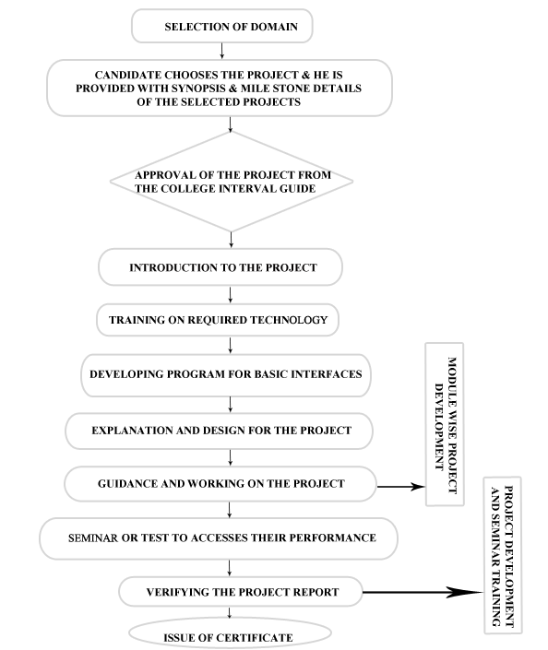

SOFTWARE PROJECTS

JAVA PROJECTS
NETWORKING:

- LIGHTWEIGHT SECURE SCHEME FOR DETECTING PROVENANCE FORGERY AND PACKET DROP ATTACKS IN WIRELESS SENSOR NETWORKS
- SMARTCRAWLER: A TWO-STAGE CRAWLER FOR EFFICIENTLY HARVESTING DEEP-WEB
- A NOVEL AND LIGHTWEIGHT SYSTEM TO SECURE WIRELESS MEDICAL SENSOR NETWORKS
- CIPHER X RAY
- A TWO STAGE DEANONYMIZATION ATTACK AGAINST ANONYMIZED SOCIAL NETWORKS
- AN IMPROVED CLUSTERING ALGORITHM BASED ONK-MEANS AND HARMONY SEARCH OPTIMIZATION
- A HIGHLY SCALABLE KEY PRE-DISTRIBUTION SCHEME FOR WIRELESS SENSOR NETWORKS
- VAMPIRE ATTACKS
- MOBILE RELAY CONFIGURATION IN DATA - INTENSIVE WIRELESS SENSOR NETWORKS
- M-PRIVACY FOR COLLABRATIVE DATA PUBLISHING
- AMPLE:AN ADAPTIVE TRAFFIC ENGINEERING SYSTEM BASED ON VIRTUAL ROUTING TOPOLOGIES
- AUTOMATIC RECONFIGURATION FOR LARGE SCALE RELIABLE FOR STORAGE SYSTEM
- AVMON.
- P2PPROXY.
- BIDIRECTIONAL ROUTING ALGORITHUM.
- CREDIT CARD FRAUD DETECTION USING HIDDEM M,ARKOV MODEL.
- EFFICIENT BROADCASTING WITH GURENTEED COVERAGE IN MOBILE ADHOC NETWORK.
- ONLINE HANDWRITTEN SCRIPT RECOGNITION.
- A FULLY DISTRIBUTED PROACTIVELY SECURE THRESHOLD MULTISIGNATURE SCHEME.
- NETWORK MONITORING MANAGEMENT.
- A BIDIRECTIONAL ROUTING ABSTRACTION FOR ASYMMETRIC MOBILE AD HOC NETWORKS.
- AN ACKNOWLEDGEMENT APPROACH FOR THE DETECTION OF ROUTING MISBEHAVIOUR IN MANETS.

ADHOC NETWORKS:
- TAM TIERED AUTHENTICATION OF MULTICAST PROTOCOL FOR ADHOC NETWORK
- CROSS LAYER APPROACH IN MOBILE ADHOC NETWORK
- PACKET SNIFFER IN AD-HOC NETWORKS
- TAM A TIERED AUTHENTICATION OF MULTICAST PROTOCOL FOR AD-HOC NETWORKS
- THROUGHPUT AND ENERGY EFFICIENCY IN WIRELESS AD HOC NETWORKS WITH GAUSSIAN CHANNELS

CLOUD COMPUTING:

- A COMPUTATIONAL DYNAMIC TRUST MODEL FOR USER AUTHORIZATION
- AUDIT-FREE CLOUD STORAGE VIA DENIABLE ATTRIBUTE-BASED ENCRYPTION
- CHARM: A COST-EFFICIENT MULTI-CLOUD DATA HOSTING SCHEME WITH HIGH AVAILABILITY
- KEY-AGGREGATE CRYPTOSYSTEM FOR SCALABLE DATA SHARING IN CLOUD STORAGE
- PROVABLE MULTICOPY DYNAMIC DATA POSSESSION IN CLOUD COMPUTING SYSTEMS
- SECURE AUDITING AND DEDUPLICATING DATA IN CLOUD
- RELIABLE RE-ENCRYPTION IN UNRELIABLE CLOUD
- A LOAD BALANCING MODEL BASED ON CLOUD PARTITIONING FOR THE PUBLIC CLOUD
- AMES-CLOUD
- PRIVACY-PRESERVING PUBLIC AUDITING FOR SECURE CLOUD STORAGE
- AUTOMATIC PROTOCOL BLOCKER FOR PRIVACY PRESERVING PUBLIC AUDITING IN CLOUD COMPUTING
- FOG COMPUTING:MITIGATING INSIDER DATA THEFT ATTACKS IN THE CLOUD
- ENSURING DISTRIBUTED ACCOUNTABILITY FOR DATA SHARING IN THE CLOUD
- AN EFFICIENT SECURITY MODEL IN CLOUD COMPUTING BASED ON SOFT COMPUTING TECHNIQUES
- SECURE AND PRACTICAL OUTSOURCING OF LINEARPROGRAMMING IN CLOUD COMPUTING
- FUZZY KEYWORD SEARCH OVER ENCRYPTED DATA IN CLOUD COMPUTING.
- DYNAMIC LOAD-BALANCED MULTICAST FOR DATA INTENSIVE APPLICATION ON
CLOUDS.

DATA MINING

ENTITY LINKING WITH A KNOWLEDGE BASE: ISSUES, TECHNIQUES, AND SOLUTIONS.
- A META-TOP-DOWN METHOD FOR LARGE-SCALE HIERARCHICAL CLASSIFICATION
- SECURE DISTRIBUTED DEDUPLICATION SYSTEMS WITH IMPROVED RELIABILITY
- ADVANCE MINING OF TEMPORAL HIGH UTILITY ITEMSET
- SLICING A NEW APPROACH TO PRIVACY PRESERVING DATA PUBLISHING
- FAST NEAREST NEIGHBOR SEARCH WITH KEYWORDS
- DISEASE PREDICTION
- FAST DATA RETRIEVAL FROM DATABASES BEYOND THE DATABASE DIMENSIONS
- C-TREND: TEMPORAL CLUSTER GRAPHS FOR IDENTIFYING AND VISUALIZING TRENDS IN MULTI ATTRIBUTE TRANSACTIONAL DATA
- A SIGNATURE-BASED INDEXING METHOD FOR EFFICIENT CONTENTBASED RETRIEVAL OF RELATIVETEMPORAL PATTERNS
- HIDING SENSITIVE ASSOCIATION RULES WITH LIMITED SIDE EFFECTS
- EVENTUAL CLUSTERER: A MODULAR APPROACH TO DESIGNING HIERARCHICAL CONSENSUS.

MOBILE COMPUTING:
- FAST DATA COLLECTION IN TREE-BASED WIRELESS SENSOR NETWORKS

MULTIMEDIA:
- LEARN TO PERSONALIZED IMAGE SEARCH FROM THE PHOTO SHARING WEBSITES
- TRUST MODELING IN SOCIAL TAGGING OF MULTIMEDIA CONTENT

SECURE COMPUTING:
- DOUBLEGUARD DETECTING INTRUSIONS IN MULTI-TIER WEB APPLICATIONS
- ENSURING DISTRIBUTED ACCOUNTABILITY FOR DATA SHARING IN THE CLOUD
- ONLINE MODELING OF PROACTIVE MODERATION SYSTEM FOR AUCTION FRAUD DETECTION
- PACKET-HIDING METHODS FOR PREVENTING SELECTIVE
- RISK-AWARE MITIGATION

WIRELESS COMMUNICATION
- AN ADAPTIVE OPPORTUNISTIC ROUTING SCHEME FOR WIRELESS AD-HOC NETWORKS
- CUT DETECTION IN WIRELESS SENSOR NETWORKS

IMAGE PROCESSING
- AUTOMATIC FACE NAMING BY LEARNING DISCRIMINATIVE AFFINITY MATRICES FROM WEAKLY LABELED IMAGES
- SUPER RESOLUTION - BASED INPAINTING
- 2D IMAGE MORPHING
- NOISE REDUCTION BY FUZZY IMAGE FILTERING
- FACE RECOGNITION USING EIGEN VALUES
- NOISE REDUCTION BY USING FUZZY IMAGE FILTERING.

NS2 BASED PROJECTS \
- A QOS-ORIENTED DISTRIBUTED ROUTING PROTOCOL FOR HYBRID WIRELESS
NETWORKS
- A STUDY ON FALSE CHANNEL CONDITION REPORTING ATTACKS IN WIRELESS NETWORKS
- AN ENERGY-BALANCED ROUTING METHOD BASED ON FORWARD-AWARE FACTOR FOR WIRELESS SENSOR NETWORKS
- AUTONOMOUS MOBILE MESH NETWORKS
- ALBA-R: LOAD-BALANCING GEOGRAPHIC ROUTING AROUND CONNECTIVITY HOLES IN WIRELESS SENSOR NETWORKS
- DEFENDING AGAINST COLLABORATIVE ATTACKS BY MALICIOUS NODES IN MANETS: A COOPERATIVE BAIT DETECTION APPROACH

IEEE BASED PROJECTS
- A COCKTAIL APPROACH FOR TRAVEL PACKAGE RECOMMENDATION
- A HYBRID CLOUD APPROACH FOR SECURE AUTHORIZED DEDUPLICATION
- A STOCHASTIC MODEL TO INVESTIGATE DATA CENTER PERFORMANCE AND QOS IN IAAS CLOUD COMPUTING SYSTEMS
- ACCURACY-CONSTRAINED PRIVACY-PRESERVING ACCESS CONTROL MECHANISM FOR RELATIONAL DATA
- AUTOMATIC TEST PACKET GENERATION
- CAPTCHA AS GRAPHICAL PASSWORDS—A NEW SECURITY PRIMITIVE BASED ON HARD AI PROBLEMS
- COOPERATIVE CACHING FOR EFFICIENT DATA ACCESS IN DISRUPTION TOLERANT NETWORKS
- COST-EFFECTIVE RESOURCE ALLOCATION OF OVERLAY ROUTING RELAY NODES
- DEALING WITH CONCEPT DRIFTS IN PROCESS MINING
- DECENTRALIZED ACCESS CONTROL WITH ANONYMOUS AUTHENTICATION OF DATA STORED IN CLOUDS

ANDROID BASED PROJECTS

ANDROID PROJECTS
- RESTRO GUIDE
- E - SHARY
- A REAL-TIME ADAPTIVE ALGORITHM FOR VIDEO STREAMING OVER MULTIPLE WIRELESS ACCESS NETWORKS
- Signature Generation for Sensitive Information Leakage in Android Applications
- PRIVACY-PRESERVING MULTI-KEYWORD RANKED SEARCH OVER ENCRYPTED CLOUD DATA
- SECURE AND PRACTICAL OUTSOURCING OF LINEAR PROGRAMMING IN CLOUD COMPUTING

ANDROIDAPPLICATION PROJECTS

- ANDROID MEETS LED BULBS IN SMART-HOME AUTOMATION.
- RESTAURENT MENU-ANDROID APPLICATION
- MOSES: SUPPORTING AND ENFORCING SECURITY PROFILES ON SMARTPHONES
- DYNAMIC GOOGLE REMOTE DATA COLLECTION
- SECURITY THREATS TO MOBILE MULTIMEDIA APPLICATIONS: CAMERA-BASED ATTACKS ON MOBILE PHONES
- EXTENDED MOBILE CAPTCHA IMPLEMENTATION
- ANDROID EVENT SCHEDULER/REMINDER APPLICATION
- ORGANIZATION BUSINESS COMMUNICATION & PLANNINGS THROUGH MOBILE REMOTE SERVER
- QUANTITATIVE AND QUALITATIVE MOBILE DATA COLLECTION
- THE APPLICATION PROTECTER FOR MOBILE MANUAL SECURITY
- BLUETOOTH CHATING ON ANDROID.
- DEVELOPMENT OF ANDROID ROBOT CAR USING ACCELEROMETER SENSORS.
- MODEL AND IMPLEMENTATION OF ROBOTIC ARM USING ANDROID.
- OFFICE AUTOMATION BASED ON ANDROID.
- DEVELOPMENT OF ANDROID ROBOT HELICOPTER USING ACCELEROMETER SENSORS.
- PLANNING AND DEVELOPMENT OF AN ELECTRONIC HEALTH RECORD CLIENT BASEDDON THE ANDROID PLATFORM.
- LOCATION TRACKING USING SMS BASED ON ANDRODID MOBILE.
- ANDROID ON MOBILE DEVICES:AN ENERGY PERSPECTIVE.
- DEVELOPMENT OF HUMAN ANDRO SYSTEM.
- ANDROID PHONE BASED DRUNK AND DRIVE DETECTION.
- PEDOMETER AN ANDROID APPLICATION.

PHP PROJECT
- I STUDENT
- CAPTCHA
- DYNAMIC IMAGE GALLERY
- CONTENT MANAGEMENT SYSTEM FOR WEBSITE
- PRINTING PRESS WEDDING CARD
- E-SURVEY PORTAL
- INVENTORY PORTAL
- E-COPS
- PERK POINT
- E-COMMERCE APPLICATION PORTAL
- BLOG/FORUM

FOR MORE PROJECT TITLES LOG ON TO
www.technofist.com
www.technofist.in
www.itcdp.in

