TECHNOFIST a leading student’s project solution providing company established in Bangalore since 2005. With perfect infrastructure, lab set up, Work shop, Expertise faculties make our self competitive service providers.
We offer projects for all branches of Engineering and Diploma students.
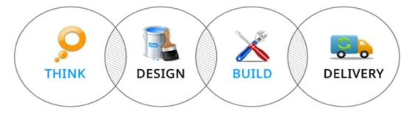
DOORS OF TECHNOLOGY:
- EMBEDDED SYSTEMS  - MICROCONTROLLERS / ARM /PIC / AVR  - WIRELESS TECHNOLOGIES  - ROBOTICS  - ARDUINO  - GSM & GPS/ ZIGBEE  - MATLAB / VLSI | - IEEE PROJECTS ON JAVA / DOT NET  - JAVA AND DOT NET APPLICATION PROJECTS  - ANDROID BASED PROJECTS  - PHP  - C,C++  - AND COMPLETE MECHANICAL FABRICATIONS
Projects are available for all branches of ENGINEERING, DIPLOMA, MCA/BCA, and MSc/BSc.
CORPORATE OFFICE:
TECHNOFIST
YES Complex,
#19/3&4, 2nd Floor,
Dinnur Main Road
R T Nagar Post
Bangalore – 32
=====================================================================
Support : 080-40969981 Sales :+91-9008001602
www.technofist.com ww.technofist.in www.itcdp.in info@technofist.com
=====================================================================

PROJECT LIST
SL No | CONTENTS
1  2  3  4 | SOFTWARE PROJECTS  - JAVA, J2EE  - PHP  - DOTNET  EMBEDDED PROJECTS  - ARM BASED PROJECTS  - ANALOG AND DIGITAL ELECTRONICS PROJECTS  - MICROCONTROLLER BASED PROJECTS  - IEEE TRANSACTIONS ON ROBOTICS  - IEEE TRANSACTIONS ON GSM  - WIRELESS BASED PROJECTS  - CELL PHONE BASED PROJECTS  - SMART CARD/ RFID BASED PROJECTS  - BIO-METRIC / BIO-MEDICAL BASED PROJECTS  - CAN PROTOCOL BASED PROJECTS  - GSM AND GPS BASED PROJECTS  - MICROCONTROLLER BASED ELECTRICAL  - BLUETOOTH BASED PROJECTS  - ZIGBEE BASED PROJECTS  - CAPSENSE, TOUCH SENSE  - MATLAB  - VLSI  ANDROID BASED PROJECTS  MECHANICAL PROJECTS

PROJECT FLOW
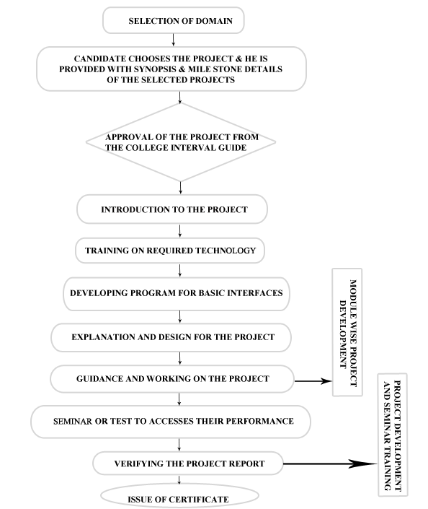

MECHANICAL PROJECTS

AUTOMOBILE BASED PROJECTS
- AUTOMATIC RAIN OPERATED WIPER HOVER CRAFT MODULE
- QUADCOPTER
- FLYWHEEL BASED REGENERATIVE BREAKING SYSTEM
- REGENERATIVE BREAKING (ELECTRIC).
- AUTOMATED METRO TRAIN
- UNMANNED FIGHTER FOR ARMY OPERATIONS
- FABRICATION OF AUTOMATIC PNEUMATIC JACK
- REMOTE CONTROLLED WHEEL CHAIR CUM BED FOR PHYSICALLY HANDICAPPED
- AUTOMATIC MATERIAL HANDLING ROBOT
- AUTO GUIDED VEHICLE
- VOICE CONTROLLED WHEEL CHAIR
- FABRICATION OF MOTORIZED SCREW JACK
- EFFICIENT CAR PARKING FOR FOUR WHEEL
- FABRICATION OF RAILWAY GATE CONTROLLER
- FABRICATION OF MOTORIZED HYDRAULIC JACK
- CAR THEFT AND ACCIDENT PREVENTER
- FABRICATION OF ELCTROMAGNETIC BREAK
- FABRICATION OF HYBRID VEHICLE

MECHANICAL PRODUCTION BASED PROJECTS

- FABRICATION OF PEDAL OPERATED WATER PUMPING SYSTEM
- AUTOMATIC CONVEYOR BELT WITH PICK AND PLACE AND DIGITAL COUNTER
- MULTI-PURPOSE OR 3 IN 1 MECHANICAL MACHINE (DRILLING,SHAPING &HACKSAW)
- PICK AND PLACE ROBOT WITH GRIPPER FOR INDUSTRIAL APPLICATIONS
- LINE FOLLOWING ROBOT WITH FORK LIFT
- PNEUMATIC BASED MECHANICAL CAN CRUSHER
- DESIGN AND DEVELOPMENT OF PNEUMATIC REVETING MACHINE
- PNEUMATIC BASED CRANEY
- AUTOMATIC 2 AND 3 POINT DRILL MACHINE
- PNEUMATIC BASED NIPPER FOR MECHANICAL INDUSTRIES
- DIGITAL COUNTING MACHINE IMPLEMENTING CONVEYOURS USING METAL DETECTION SENSOR
- PNEUMATIC RAMMING MACHINE
- FABRICATION OF BOARD CLEANER MECHANISM USING RACK AND PINION
- AUTOMATIC HAND WASH AND SOAP SOLUTION
- AUTOMATIC PVC PIPE FEEDING AND CUTTING MACHINE
- PORTABLE VEGETABLE CUTTER AND SLICER
- PEDAL OPRATED CELL PHONE CHARGER
- FABRICATION OF ROTATING FORK LIFT
- LINE FOLLOWING ROBOT WITH FORK LIFT
- FABRICATION OF GLASS CLEANING MECHANISM
- FABRICATION OF GROUND NUT THRUSTER
- FULLY AUTOMATIC CHAPPATI MAKING MACHINE
- HYDRAULIC PORTABLE CRANE
- FULLY AUTOMATED HYDRAULIC CRANE
- AUTOMATIC PNEUMATIC WISE AND JACK
AUTOMATION AND MECHATRONICS BASED PROJECTS

- AUTOMATED AND REMOTE CONTROLLED SCREW JACK SYSTEM
- PC CONTROLLED ARIEL VEHICLE FOR MILITARY APPLICATIONS
- UNMANED VEHICLE FOR TODAYS ARMY
- INTELLEGENT COMBACT ROBOT FOR MILITARY OPERATIONS
- AUTOMATIC GUN FIRING SYSTEMS FOR MILITARY APPLICATIONS
- SMART WINDOW
- CELL PHONE OPERATED LAND ROVER
- FLEX SENSOR OPERATED ROBOTIC ARM
- HAPTIC ROBOTIC ARM
- MOTOR VIBRATION CHECKER WITH SENSOR AND SPEED DISPLAY
- AUTOMATIC BELT CONVOYER WITH PICK AND PLACE AND DIGITAL COUNTER.
- PICK AND PLACE ROBOT
- AUTOMATED METRO TRAIN
- RESCUE DEVICE TO SAVE INFANTS STRUCK IN DEEP PITS
- KROTO FINDER
- WIRELESS HAPTIC COMMUNICATION IN REAL TIME ENVIRONMENT USING MECHANICAL HAND
- SUBMARINES REMOTE CONTROLLED / AUTOMATIC FOR NAVY
- SMS BASED AUTOMATIC PNEUMATIC PUNCHING MACHINE
- AUTOMATIC FOOT DUST CLEANING MACHINE
- AUTOMATED GREEN HOUSE MONITORING SYSTEM
- AUTOMATIC PAGE TURNER
- SMS CONTROLLED PICK AND PLACE ROBOT
- FABRICATION OF CONVEYOR AUTOMATION
- FABRICATION OF MUSIC CONTROLLED FOUNDATION SYSTEM
- AUTOMATIC PVC PIPE FEEDING AND CUTTING MACHINE
- AUTOMATIC RAMMING MACHINE
- AUTOMATIC DOOR OPEN AND CLOSE MECHANISM
- DESIGN AND FABRICATION OF HIGH SPEED HACKSAW MACHINE
- FABRICATION OF AUTOMATIC PNEUMATIC HAMMER
- AUTOMATIC FIRE FIGHTING CUM MATERIAL HANDLING VEHICLE
- AUTOMATIC PAINT SPRAYING VEHICLE

FABRICATION, CONVENTIONAL AND NON CONVENTIONAL PROJECTS

- FABRICATIN OF DOMESTIC WIND MILL
- FABRICATION OF SOLAR OPERATED SAFEST SAW MILL
- EFFIUCIENT POWER GENERATION AND MULTI PURPOSE UTILIZATION
- SOLAR POWER CONSERVATION WITH CHARGE CONTROLLER
- SMART DESIGN BASED HYDRO POWER GENERATION
- HUMP POWER GENERATOR
- WIND POWER UTILIZATION FOR CAR ANNUNCIATOR
- BIO GAS FURNACE USING CORN COMB
- SOLAR TRACKING SYSTEM WITH WATER PUMP
- WIND POWER UTILIZATION FOR CAR ANNUNCIATOR
- BIOGAS DIGESTER
- PUSH OPERATED SPRAY PUMP,MECHANICAL FABRICATION PROJECT
- SOLAR OPERATED AUTOMATIC RAIN WIPER
- DUAL AXIS SOLAR TRACKING SYSTEM
- THREADMILL BASED POWER GENERATION

FOR MORE PROJECT TITLES LOG ON TO
www.technofist.com
www.technofist.in
www.itcdp.in

